Cairo University Faculty of Computers and Artificial Intelligence



**Advanced SE**

**Software design specification document**

**2022**

**Project Team**

|  |  |  |
| --- | --- | --- |
| **ID** | **Name** | **Email** |
| 20200368 | Amr Tarek Mohamed | amrtarekmohamed.at@gmail.com |
| 20201083 | Zeinab Ali Ahmed | zeze1452002@gmail.com |
| 20200020 | Ahmed Sobhy Abd El Hady | devahmedsobhy@gmail.com |
| 20200681 | Omar Ahmed Abd El Rahman | omargawdaat@gmail.com |

Contents

Instructions[To be removed] 2

Class diagram design 2

Class diagram Explanation 3

Sequence diagram design 3

Github repository link 4

# Class diagram design

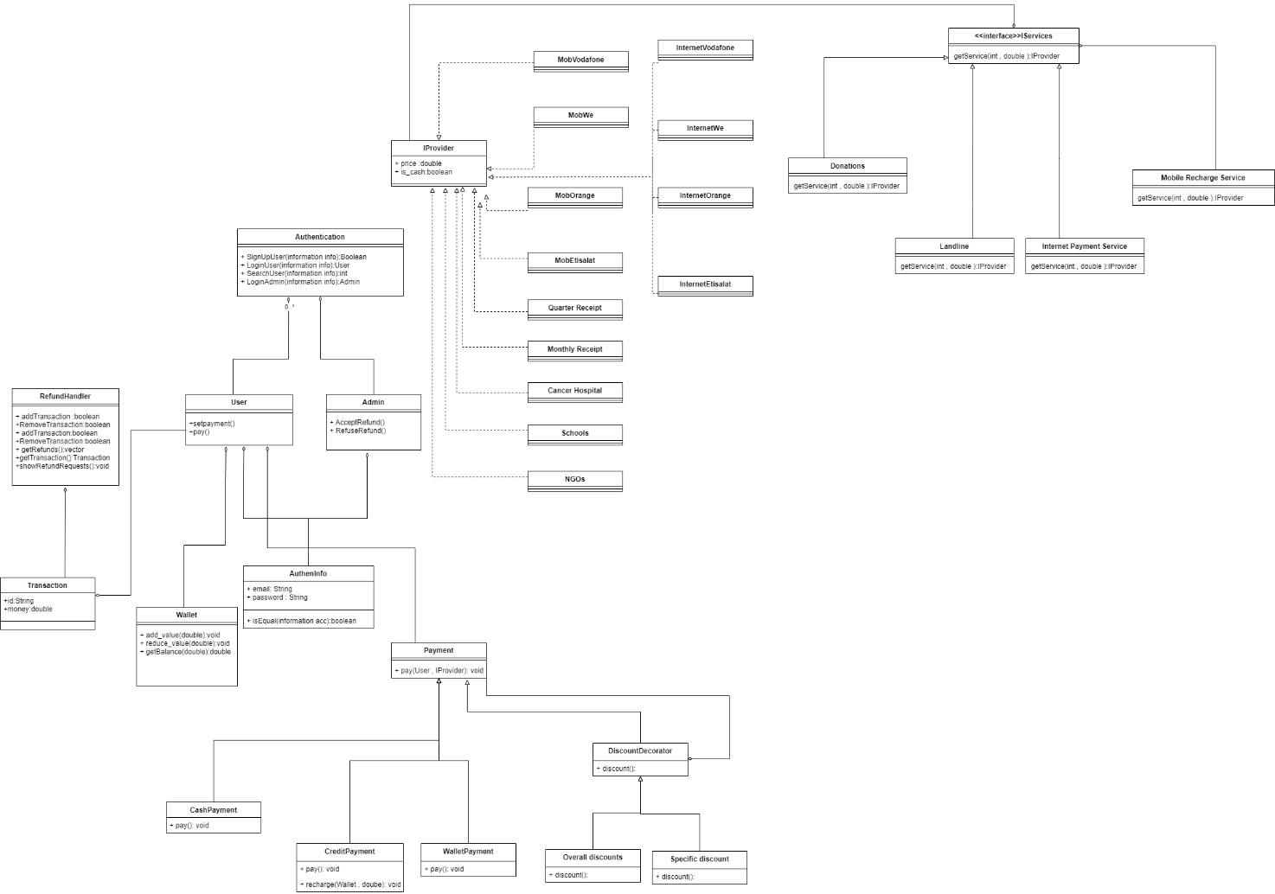

Decorator Pattern in paymen with discount classes, to extend the functionality of a certain object statically which is adding discount to total cost at run time.

Abstract Factory between Iprovider and Iservices interfaces to create families of related or dependant objects without specifiying their concrete classes, so we can choose between variety of factories and products.

# 

# Class diagram Explanation

* **Explain here the design pattern(s) that you used and your justification for using them, and the participating classes for each pattern.**

# Sequence diagram design

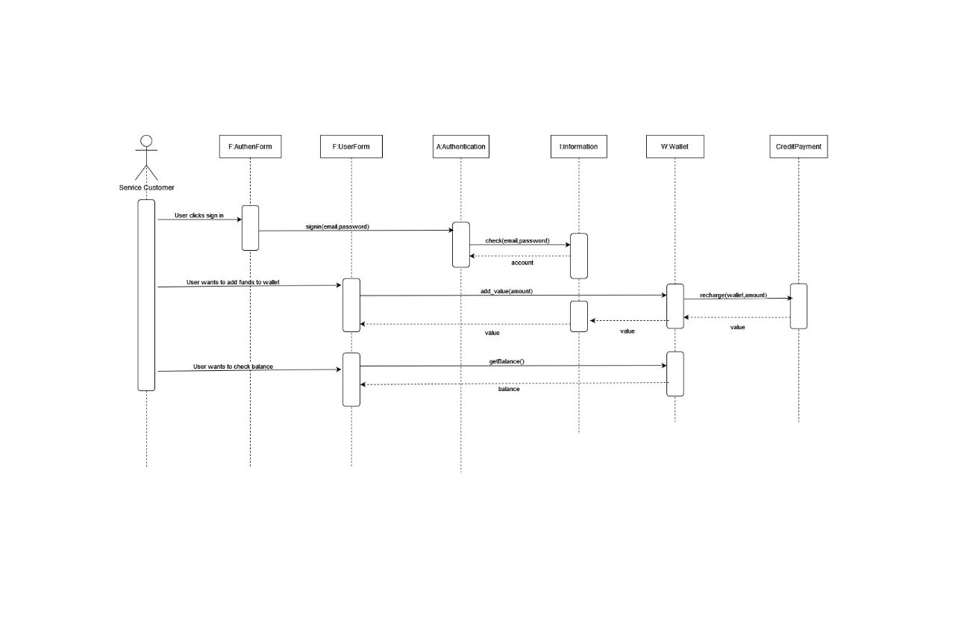

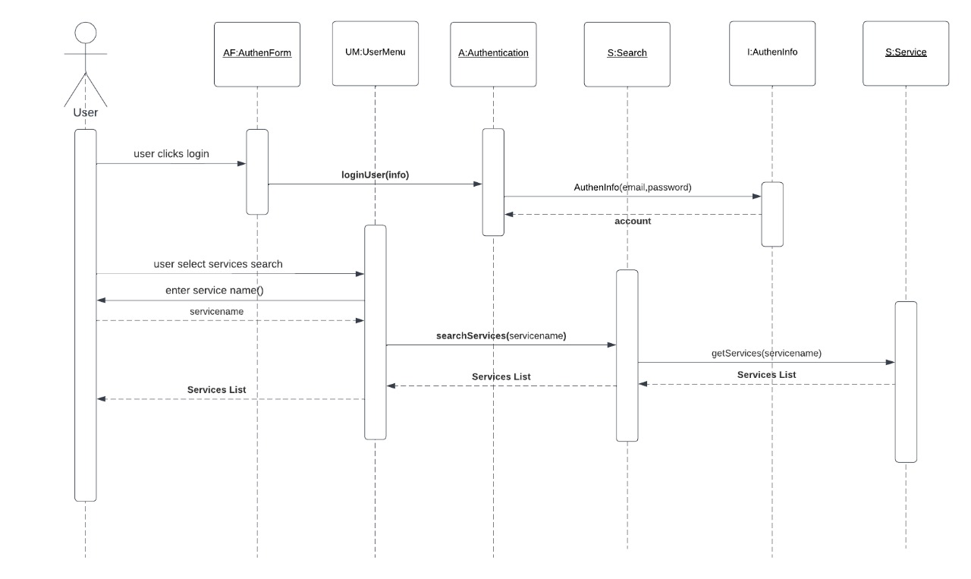

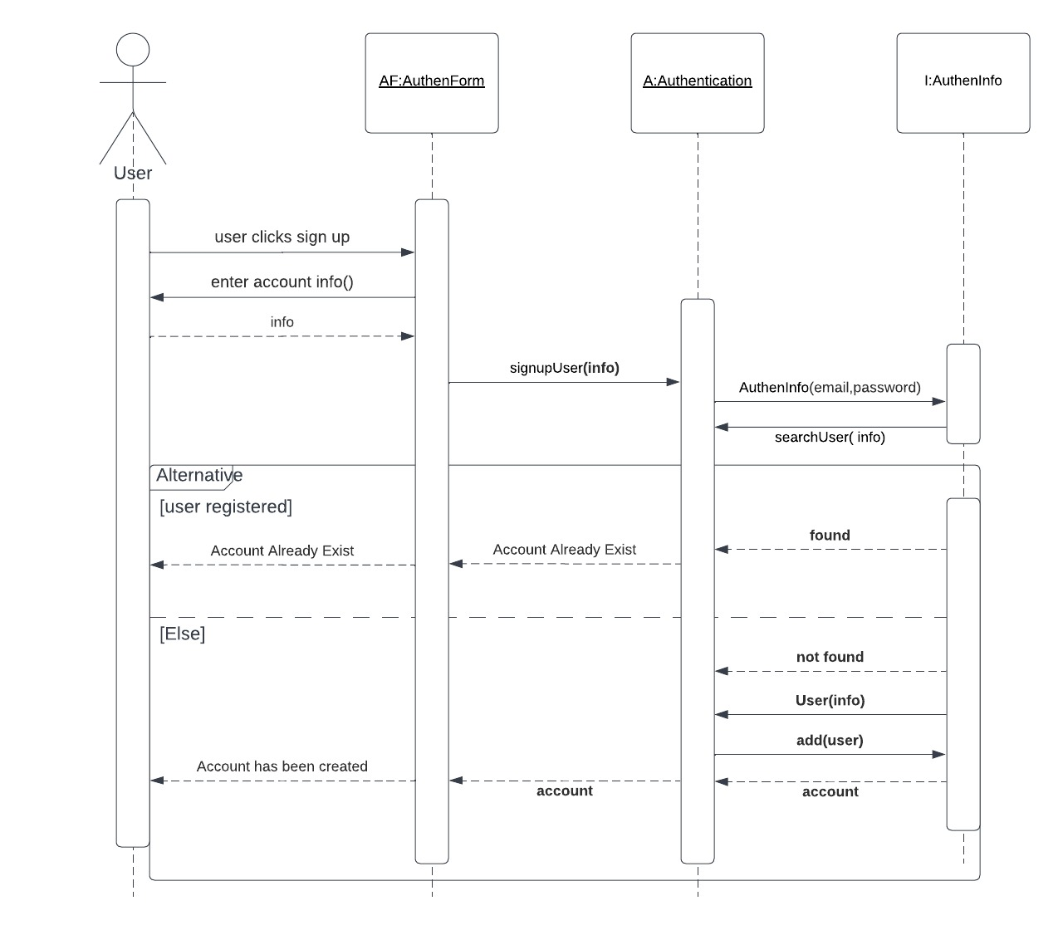

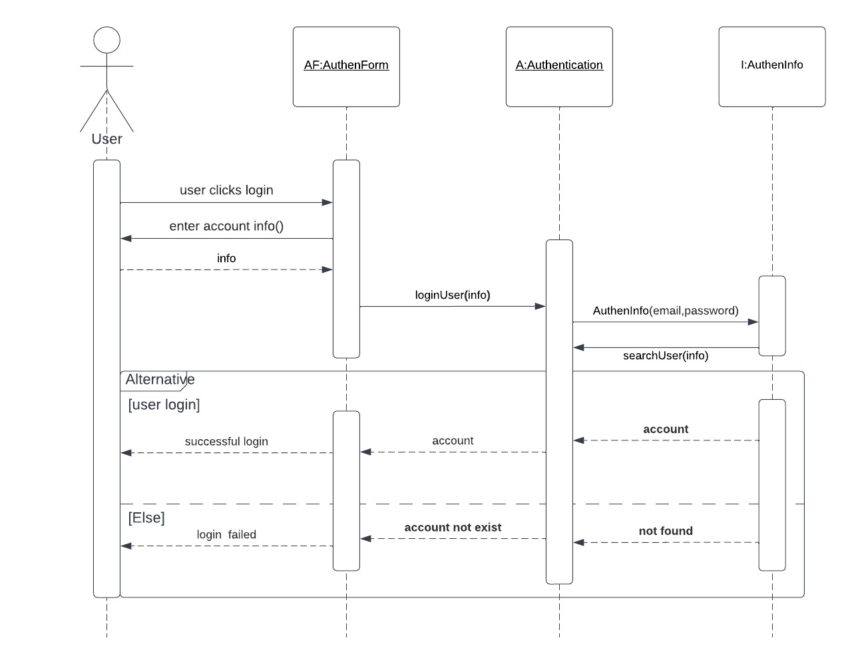

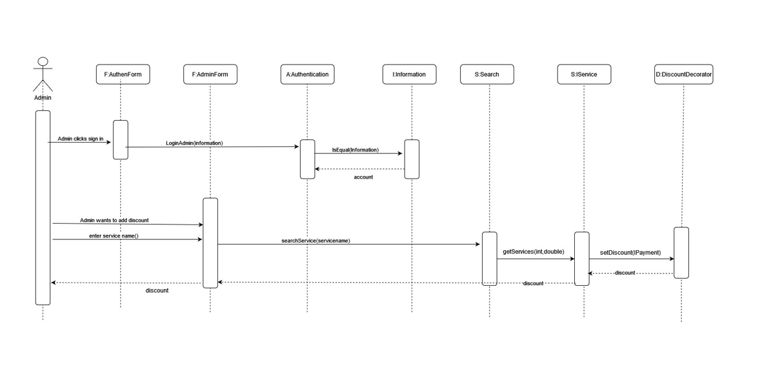

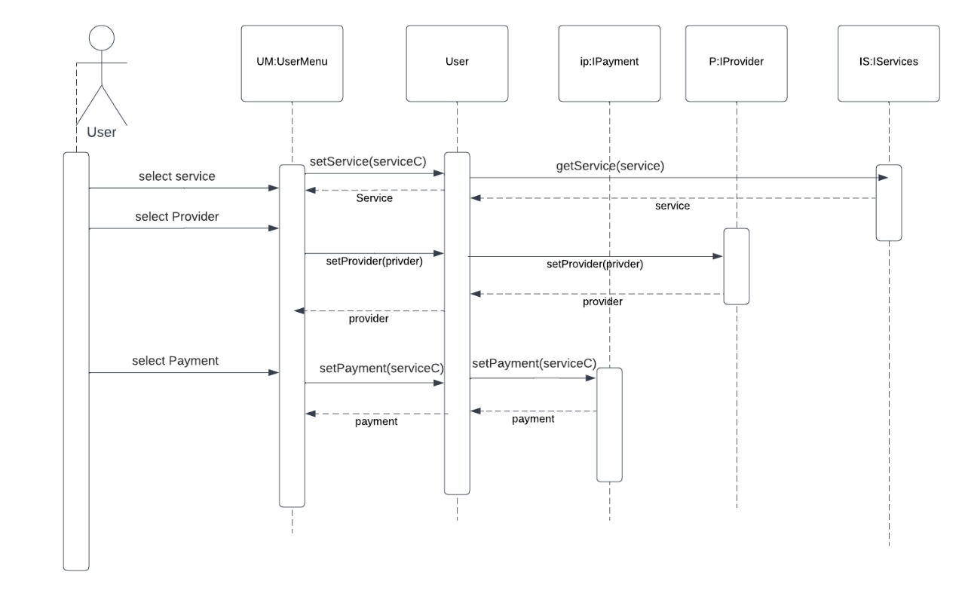

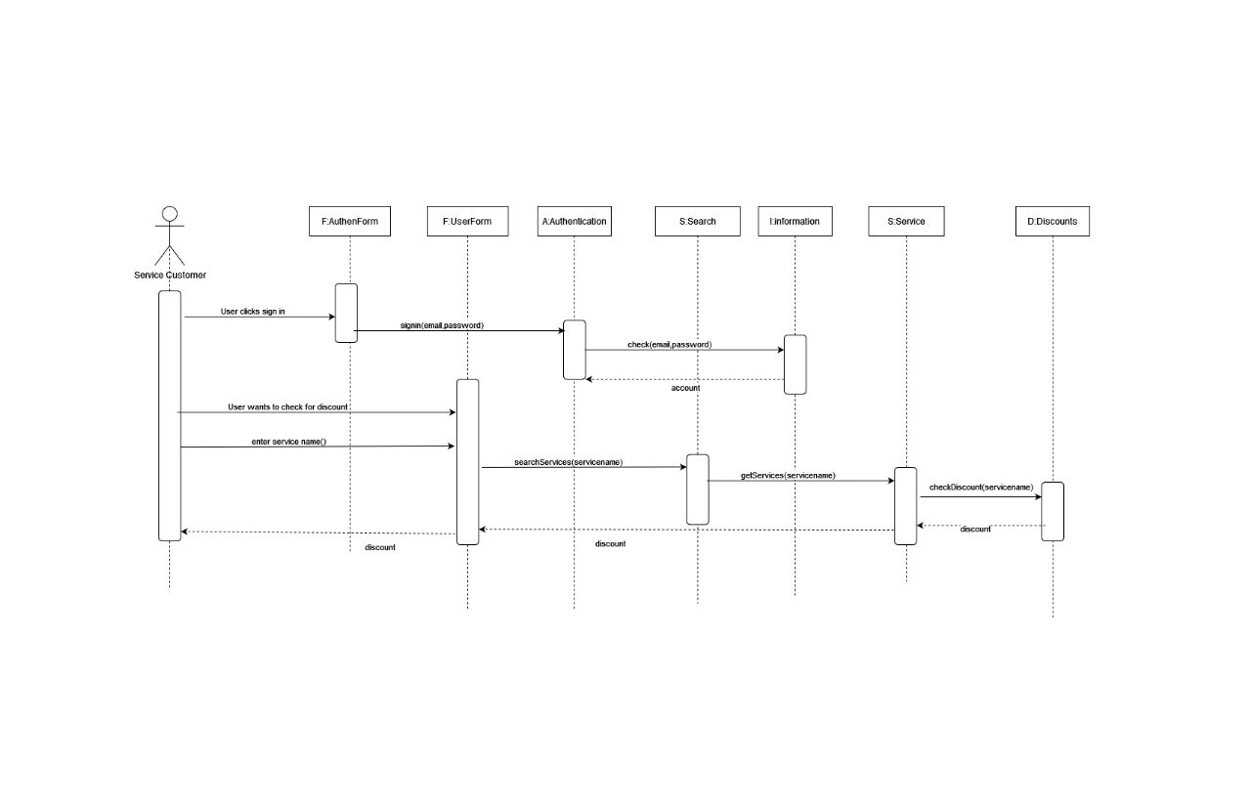

# Github repository link

* **URL for your repository, should contains implemented services**,